Normalization:

Checking the first Normal Form

No Repeating groups No Data Values are atomic NoEach field has different name Has a primary key

Checking the Second Normal Form

It is in the First Normal Form All non key attributes are dependent on ALL parts of primary key Each Field has a unique name Has a primary key

Checking Third Normal Form

It should be in second normal form All non-key attribute are not dependent on other non key attribute Each field has a unique name Has a primary key

5 Use Cases:

Case 1: Compare the metrics and also find the common Hyperparamter for like models such GBM, RANDOM FOREST, XRT

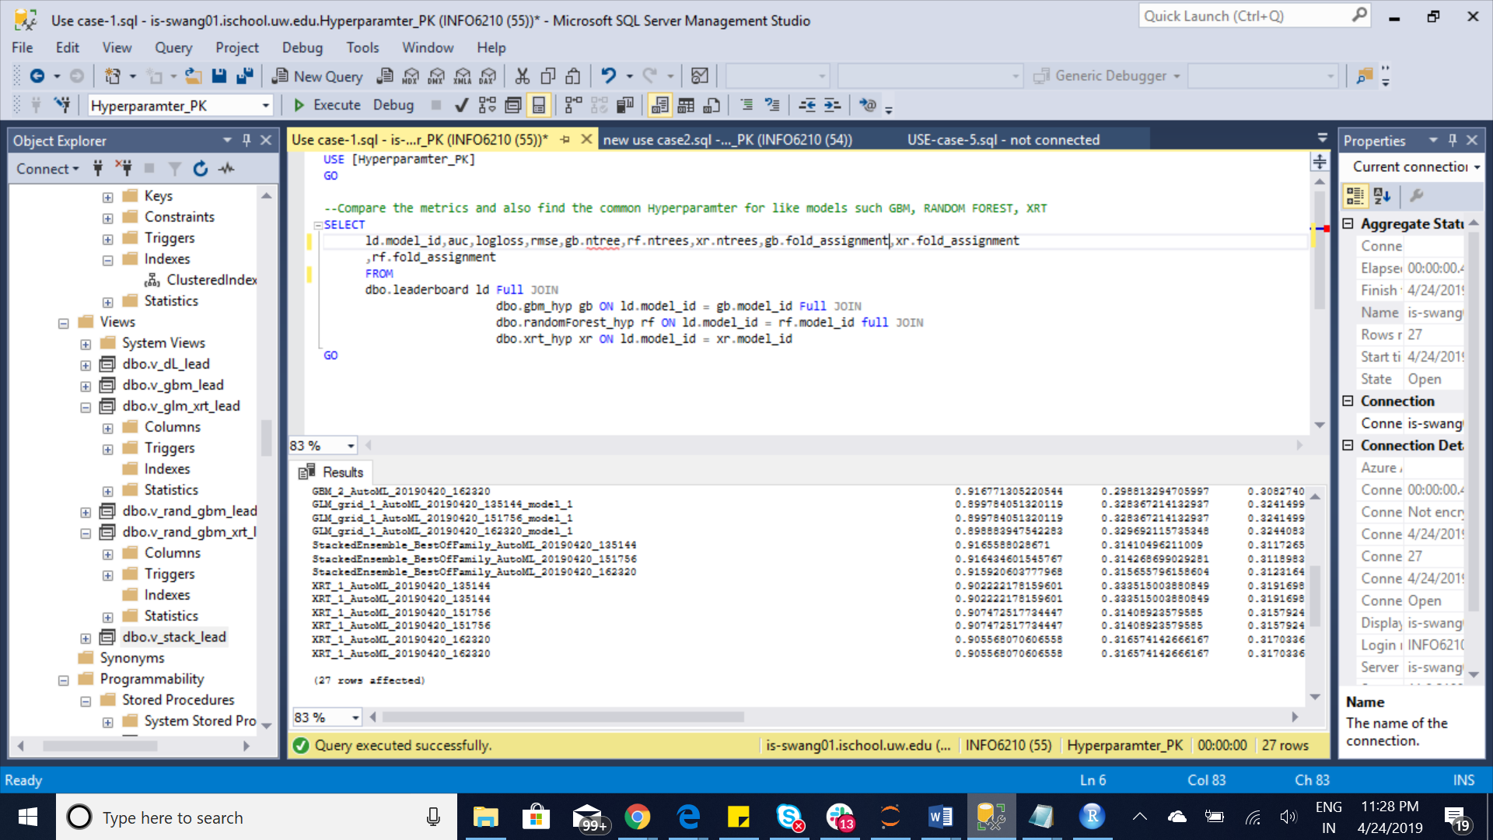

Case 2: What are the metrics for stacked ensemble model where base models are present for every model id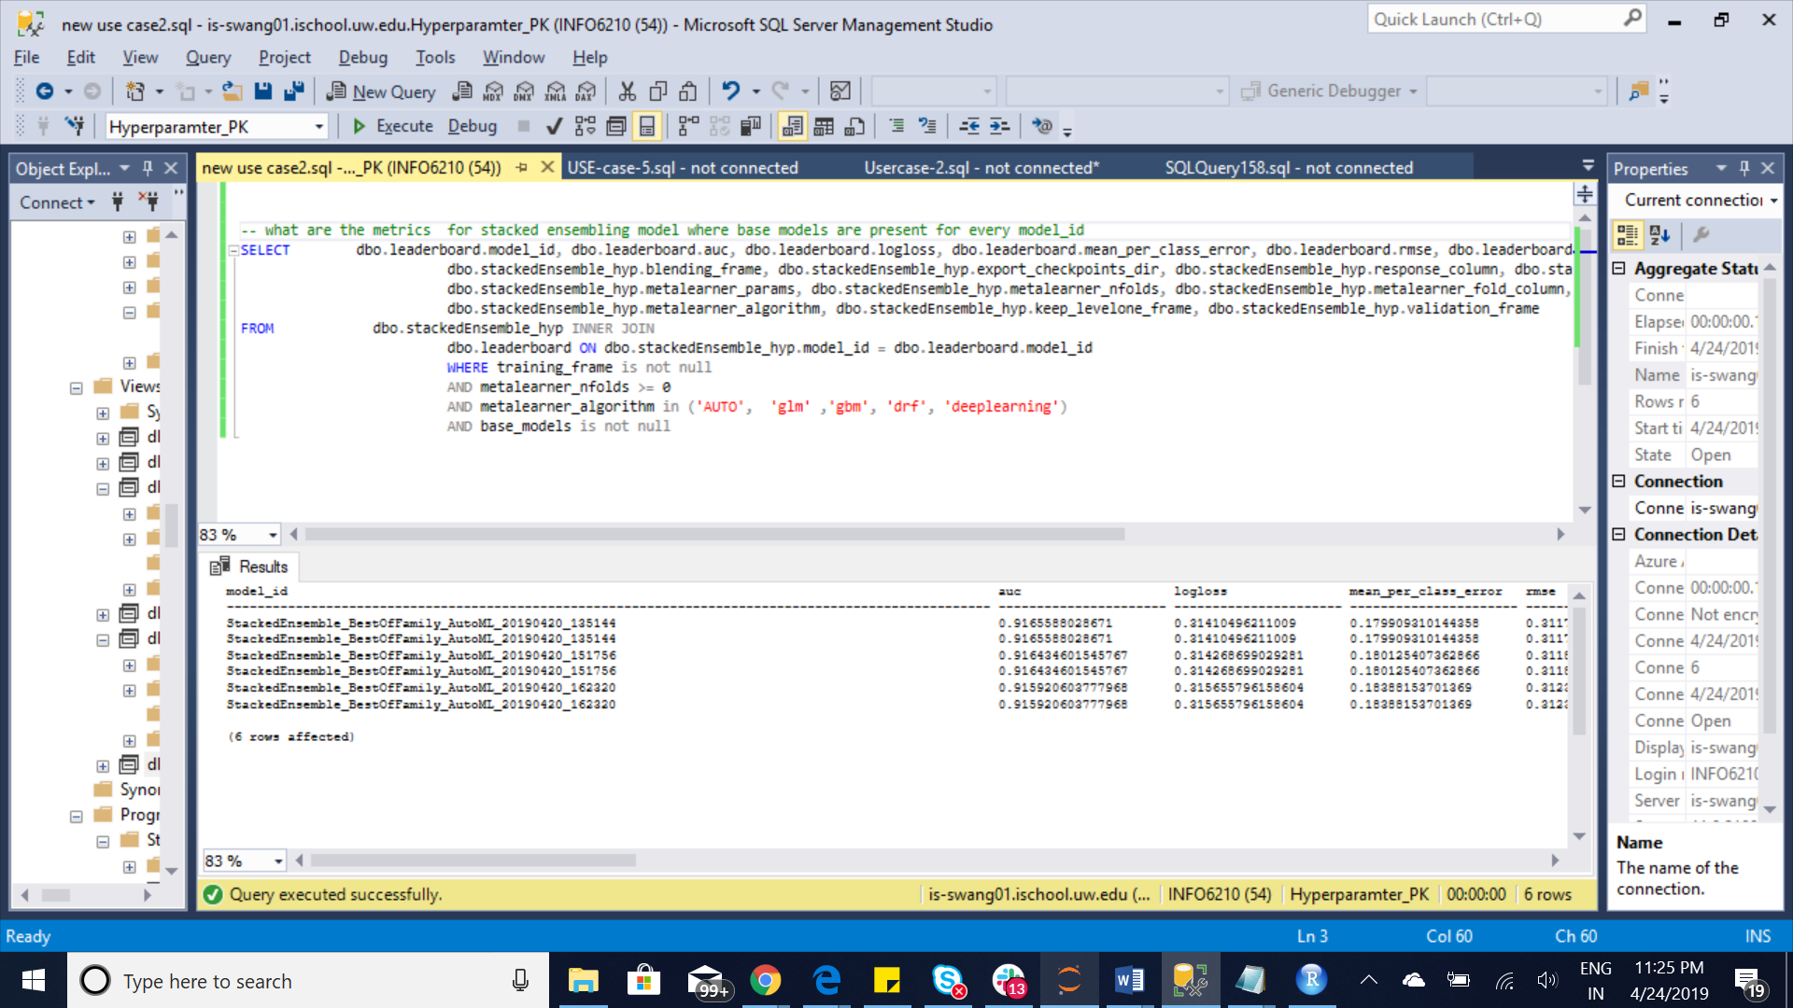

Case3: Find the Hyperparameters from GBM where number of trees are greater than 50 and distribution is either Bernoulli or multinomial min_split_improvement is between 1e-10 and 1e-3

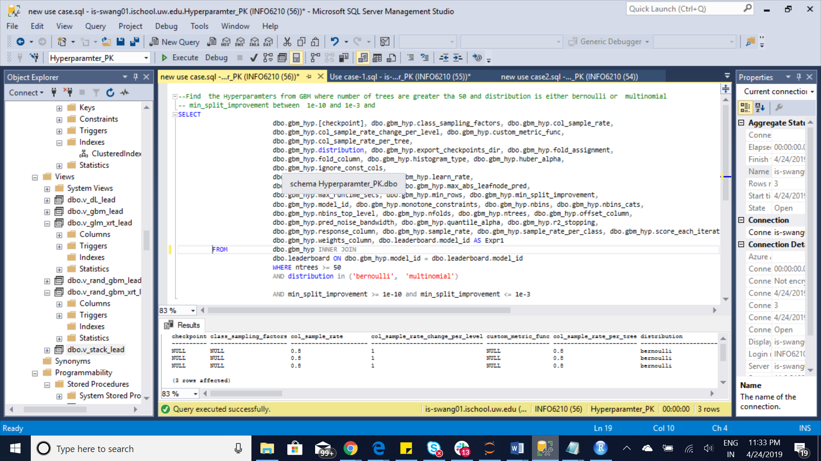

Case 4: Selecting best DRF and GLM , Deeplearning, XRT, Stacked Ensemble, GBM model

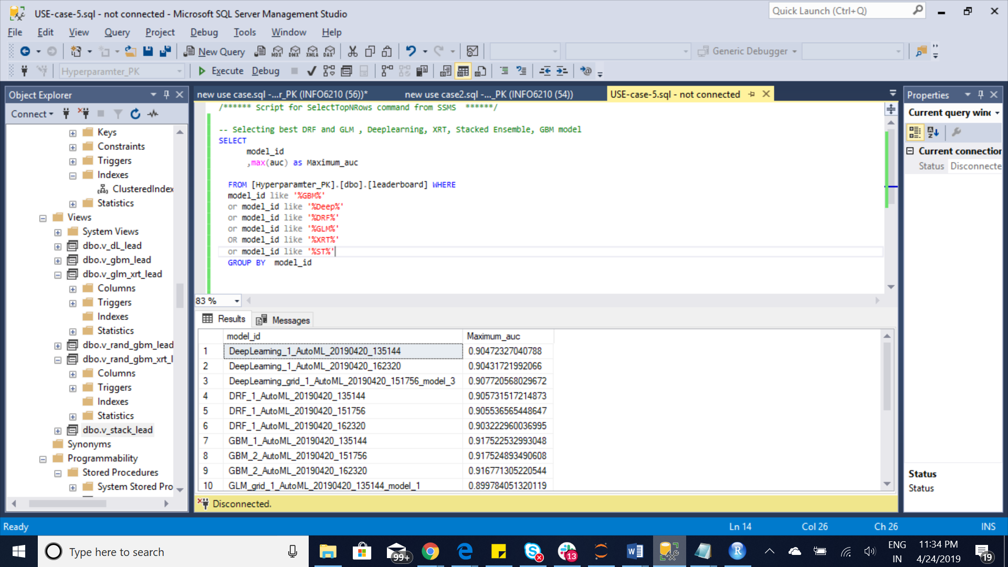

Case5 : Range of Hyperparamter and othe parameters for GBM

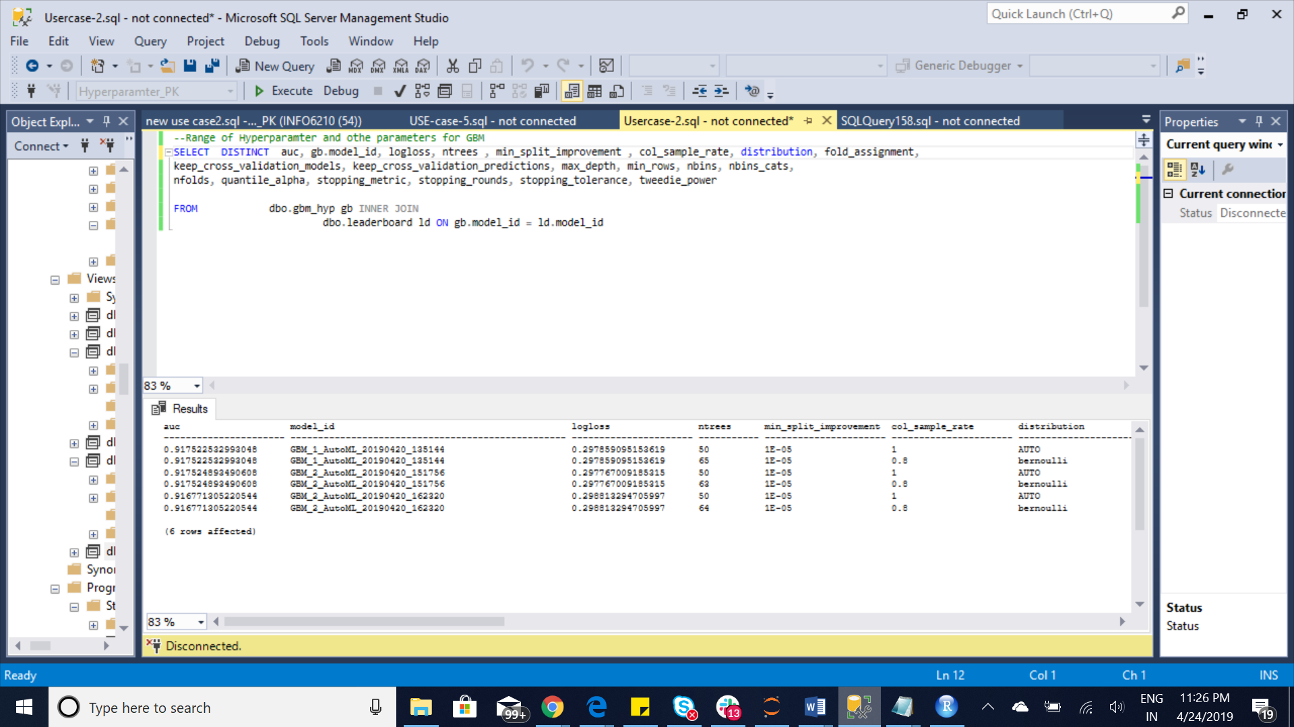

5 Views:

View1:

v_rand_-gbm_xrt_lead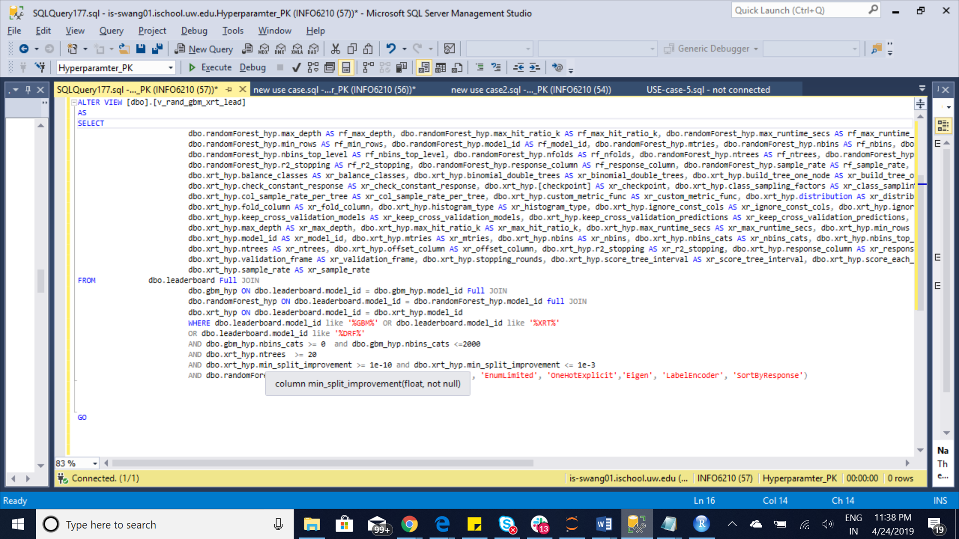

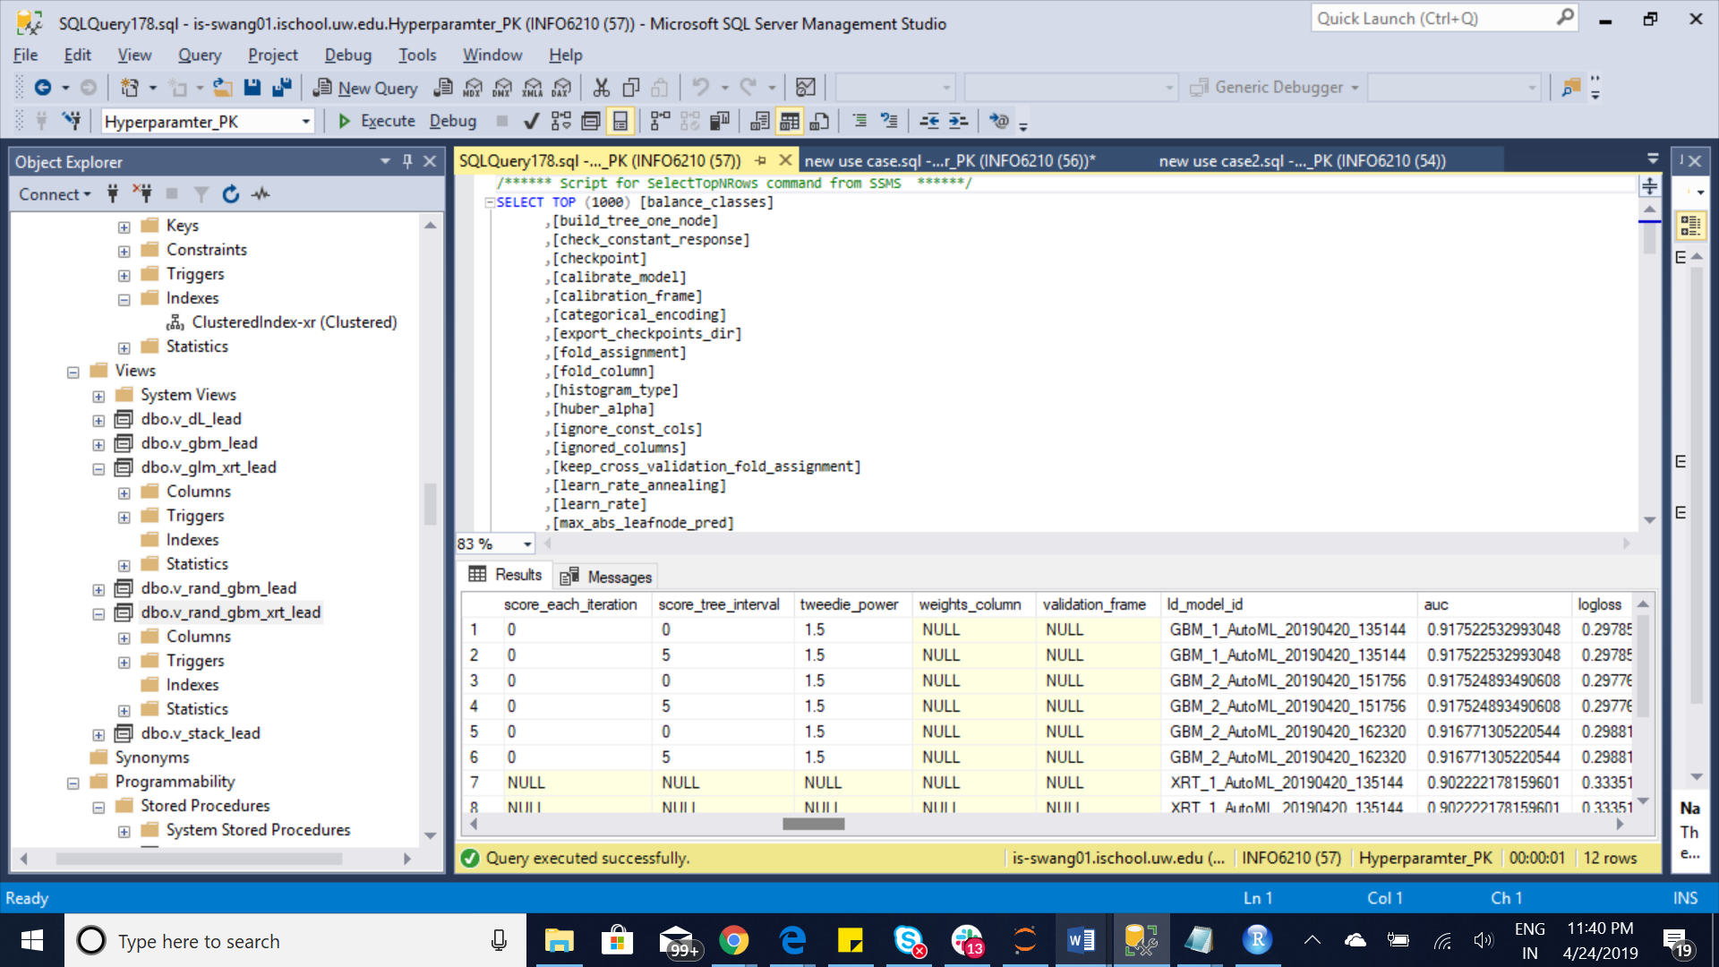

View2: [v_dL_lead]

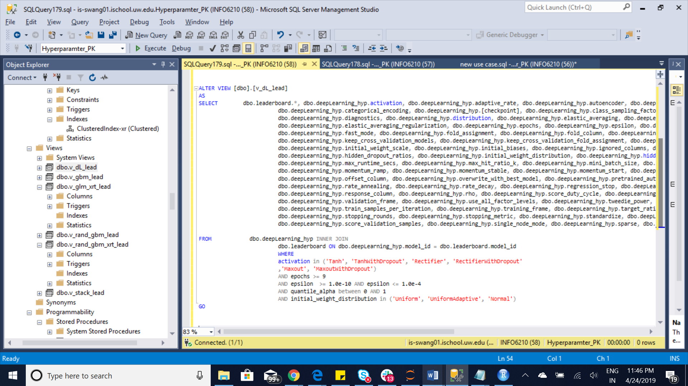

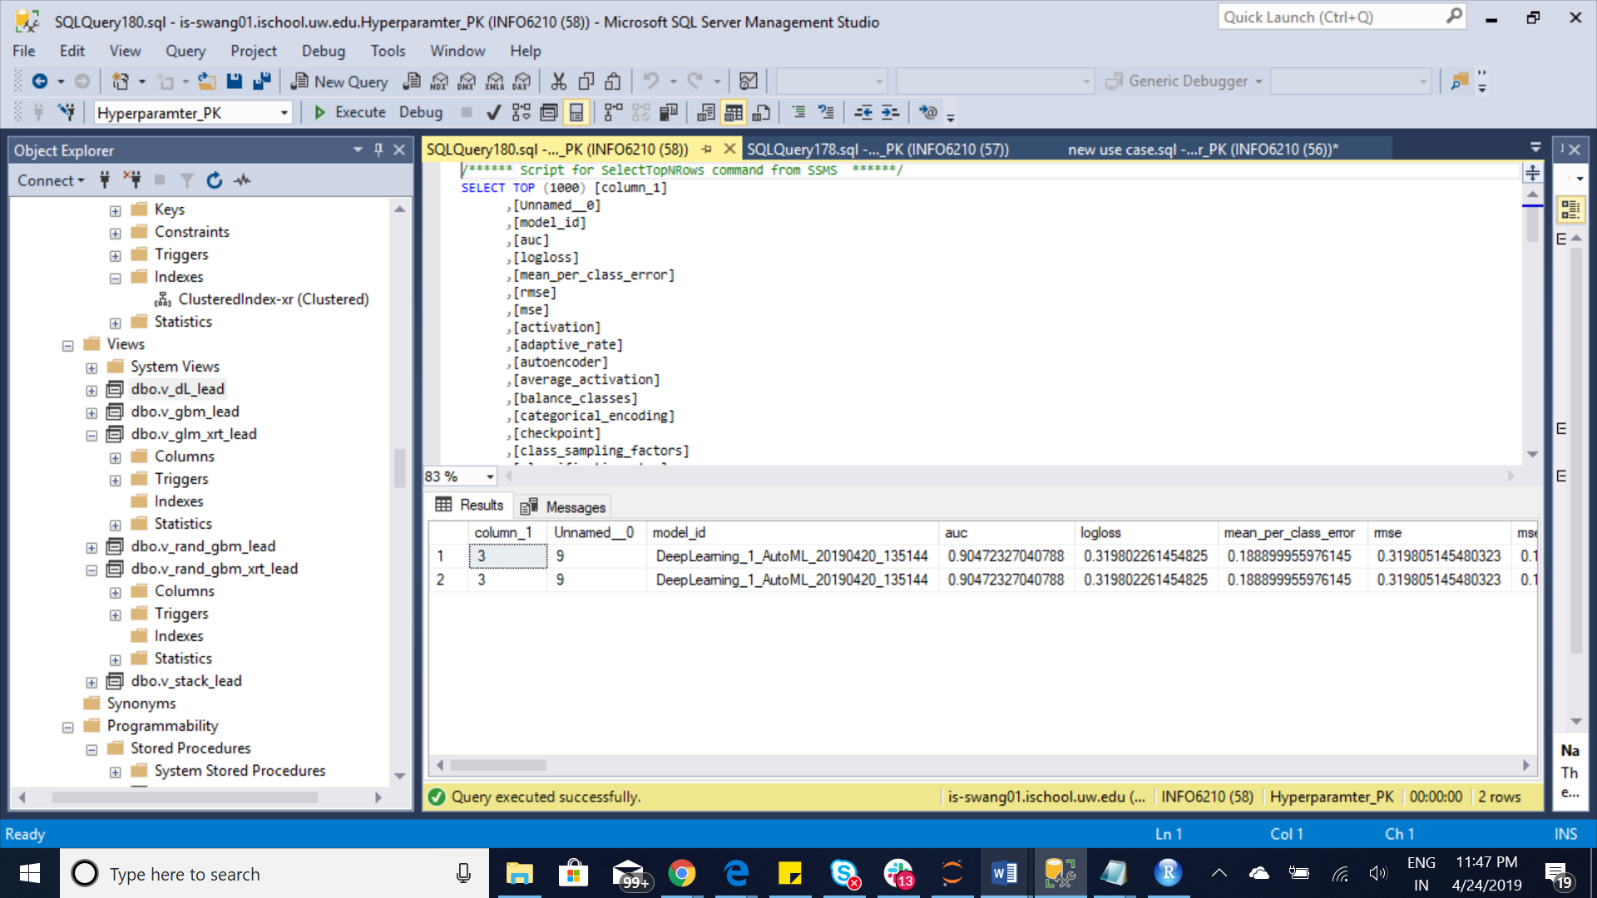

View3: v_gbm_lead

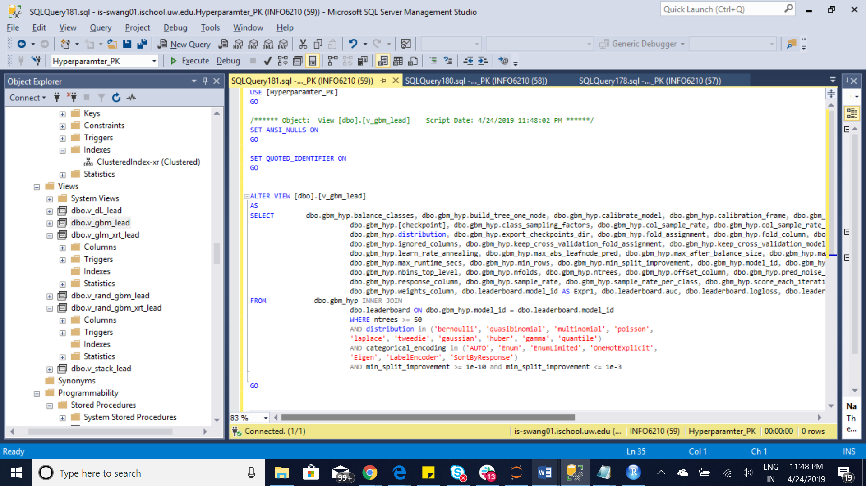

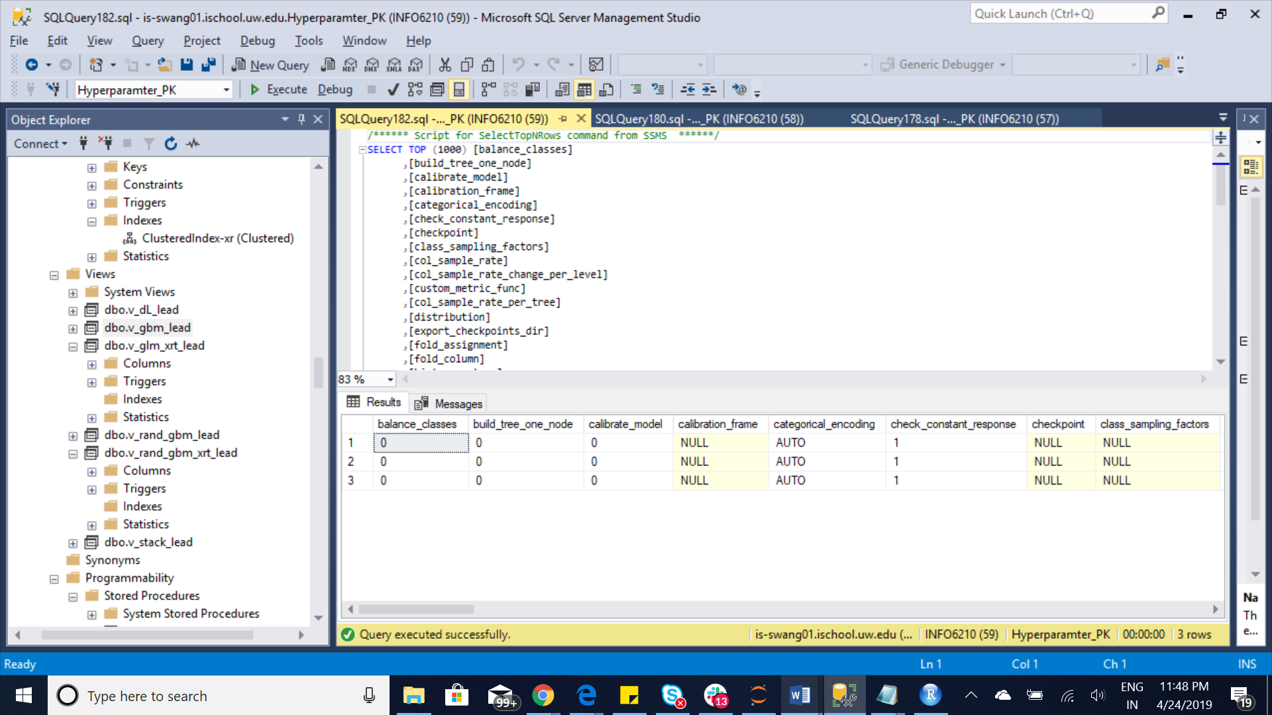

View 4: v_glm_xrt_lead

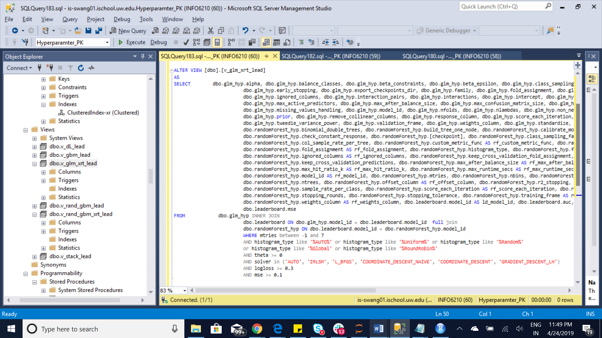

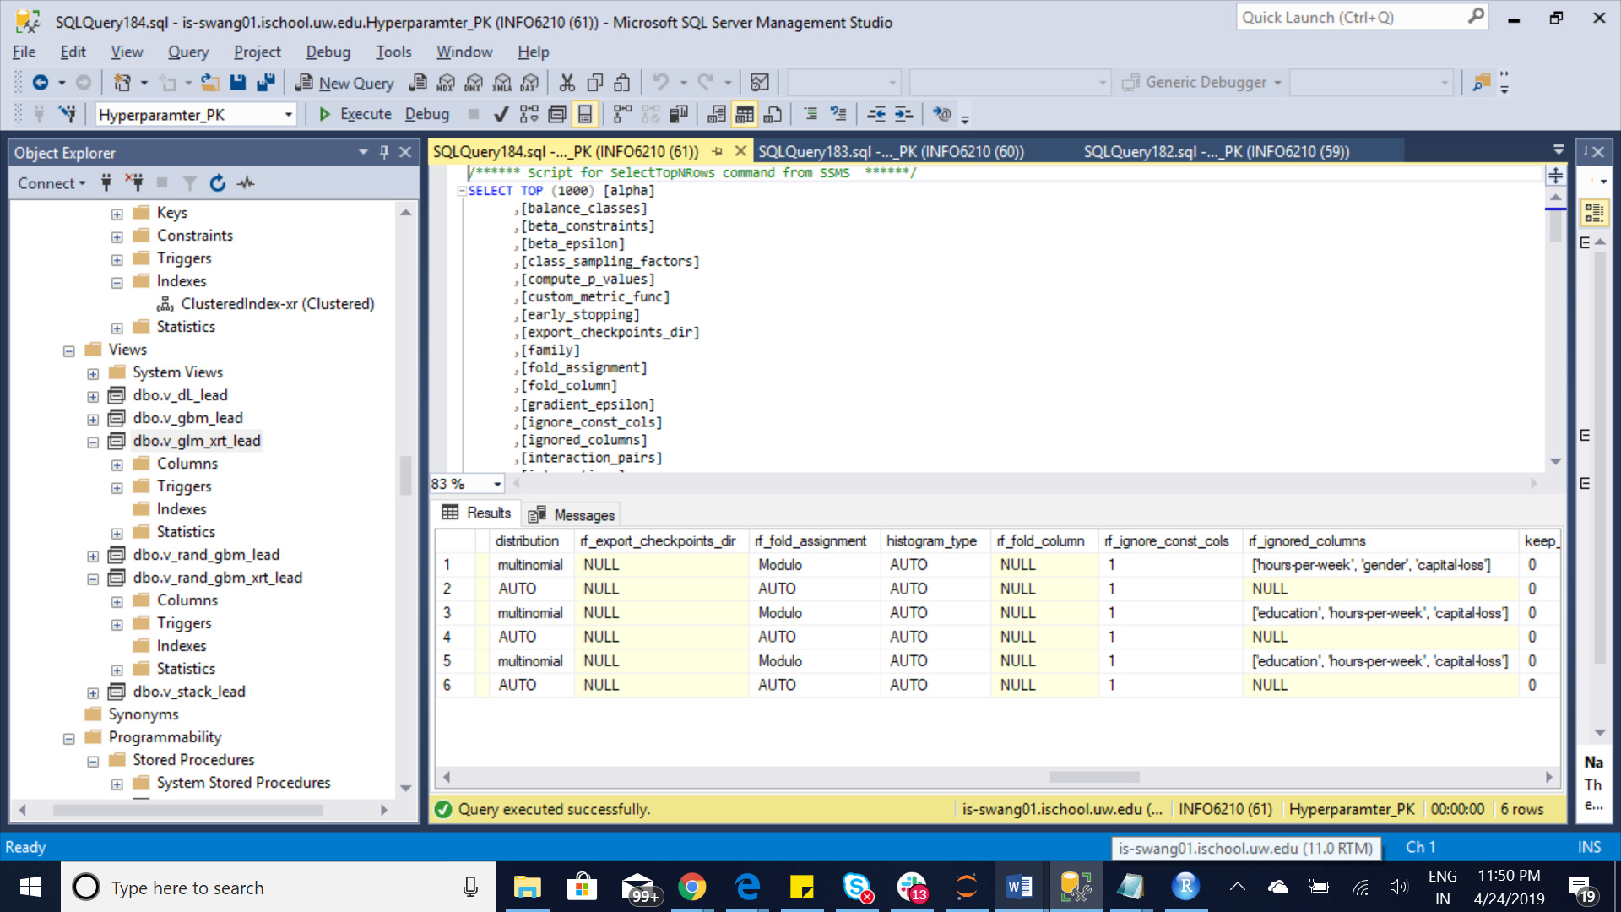

View5: v_stack_lead

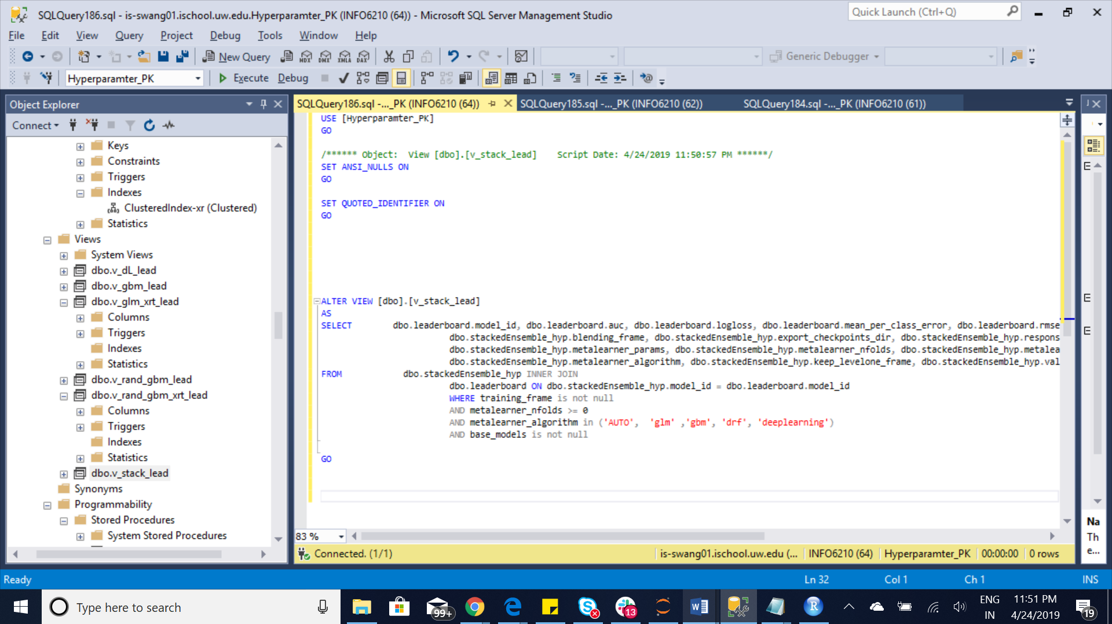

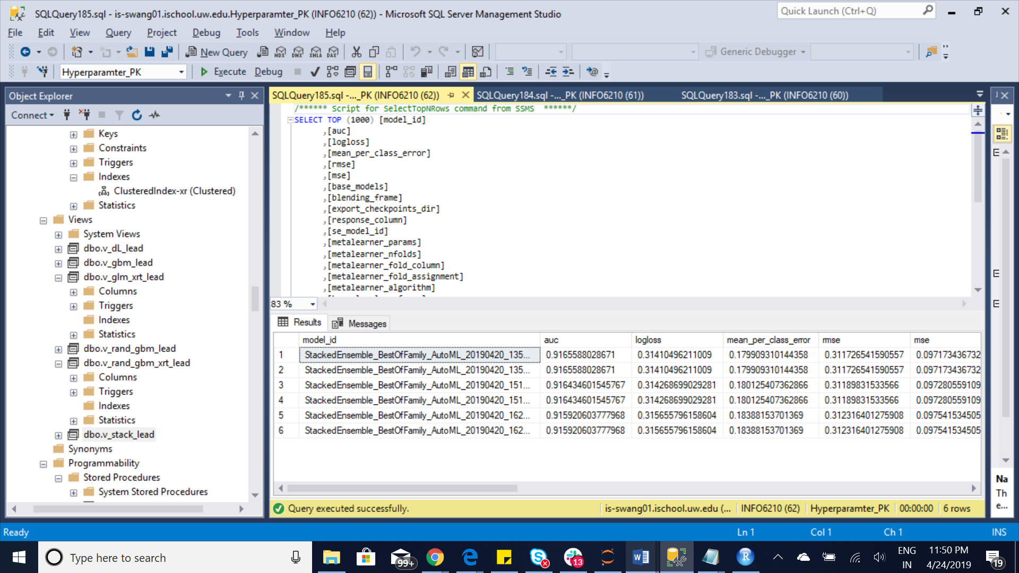

5 Functions:

Functions 1

f_gbm_lead

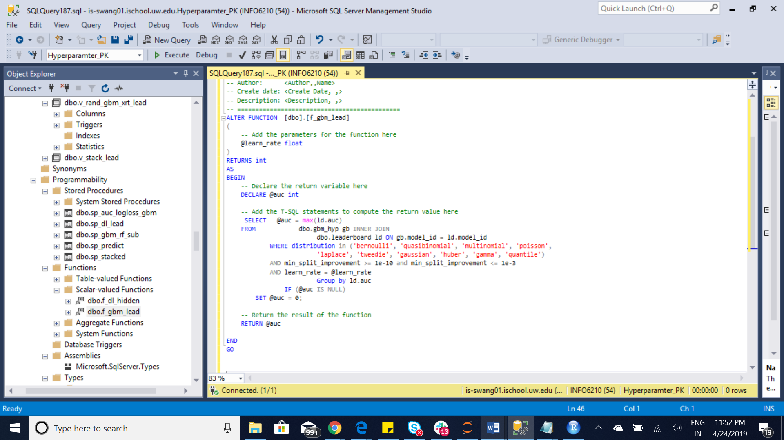

Function2: f_dl_hidden

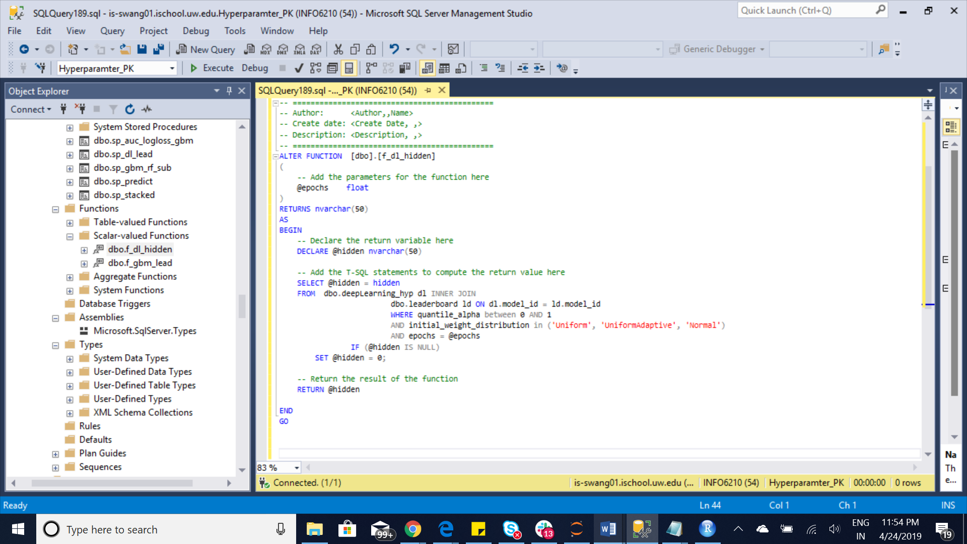

Function3: f_dt_com

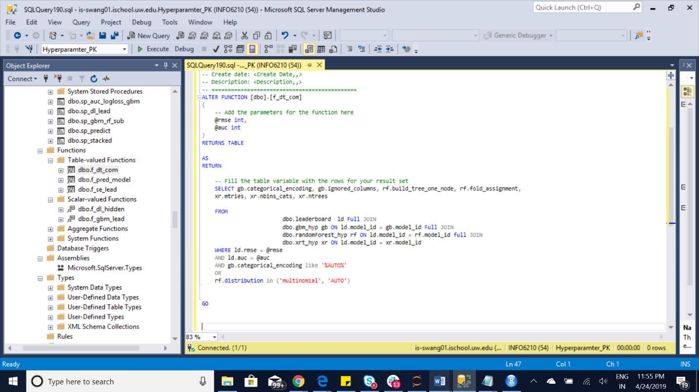

Function4: f_pred_model

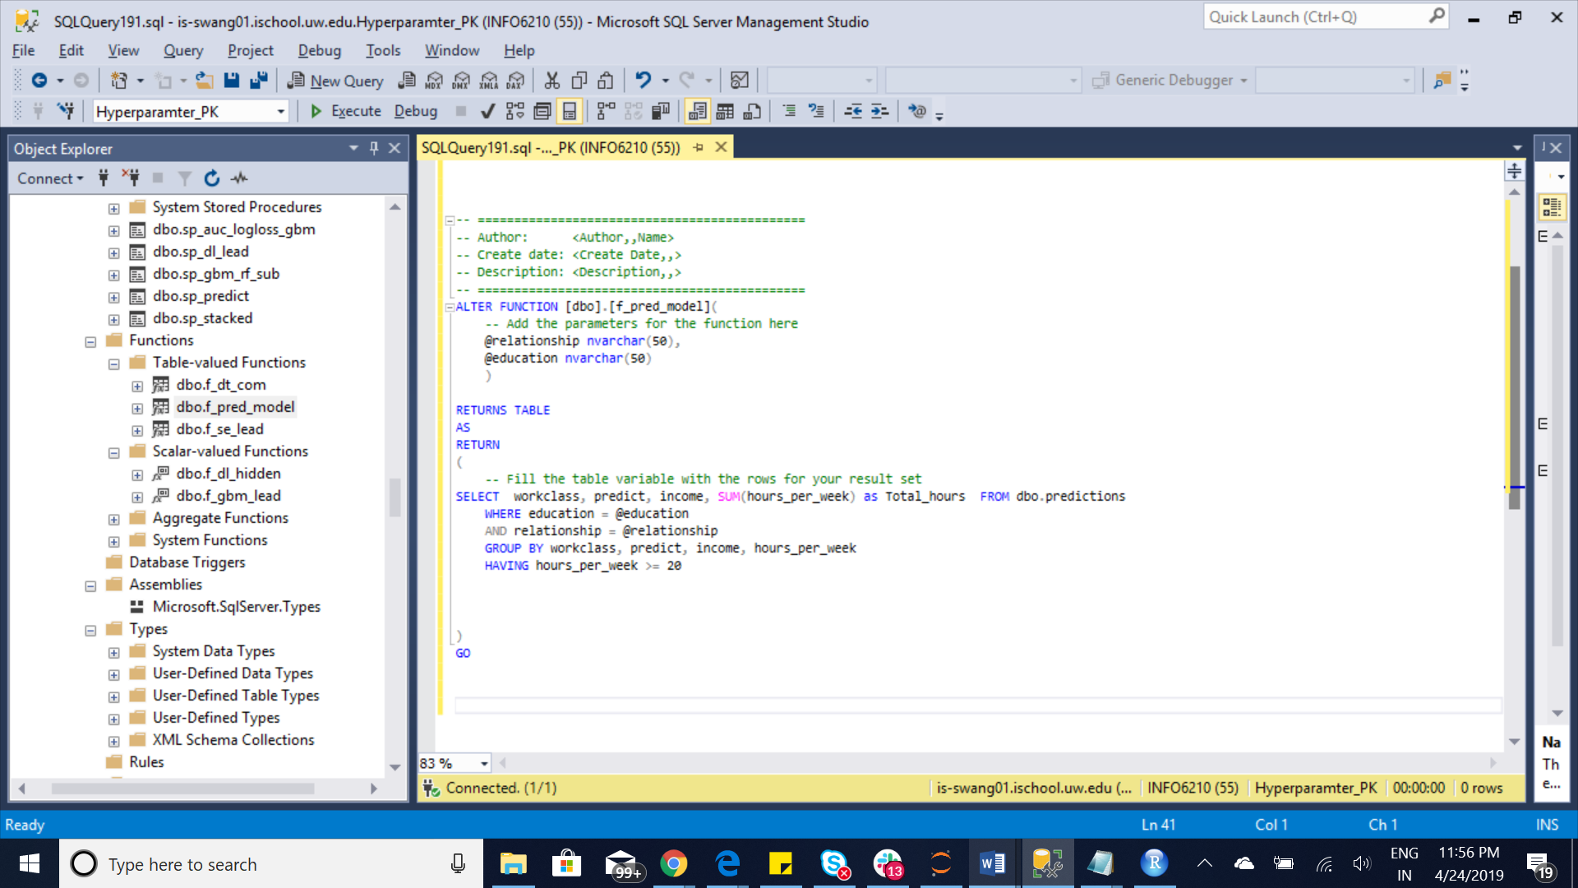

Function5: f_se_lead

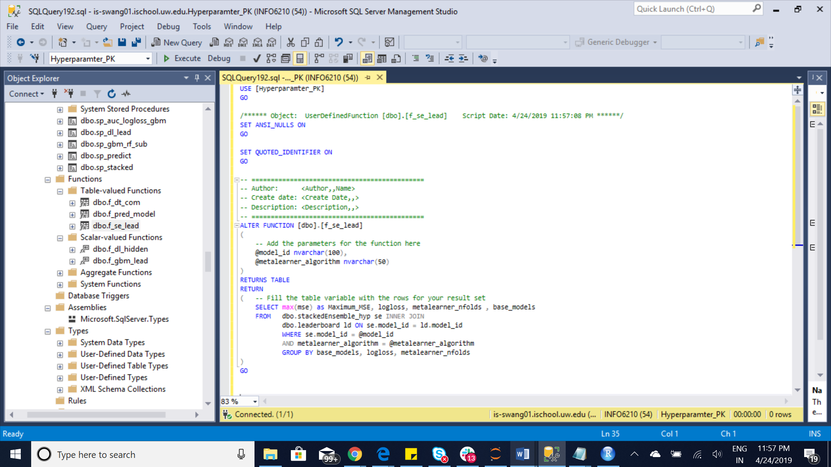

5 stored Procedures

Stored Procedure 1: sp_auc_logloss_gbm

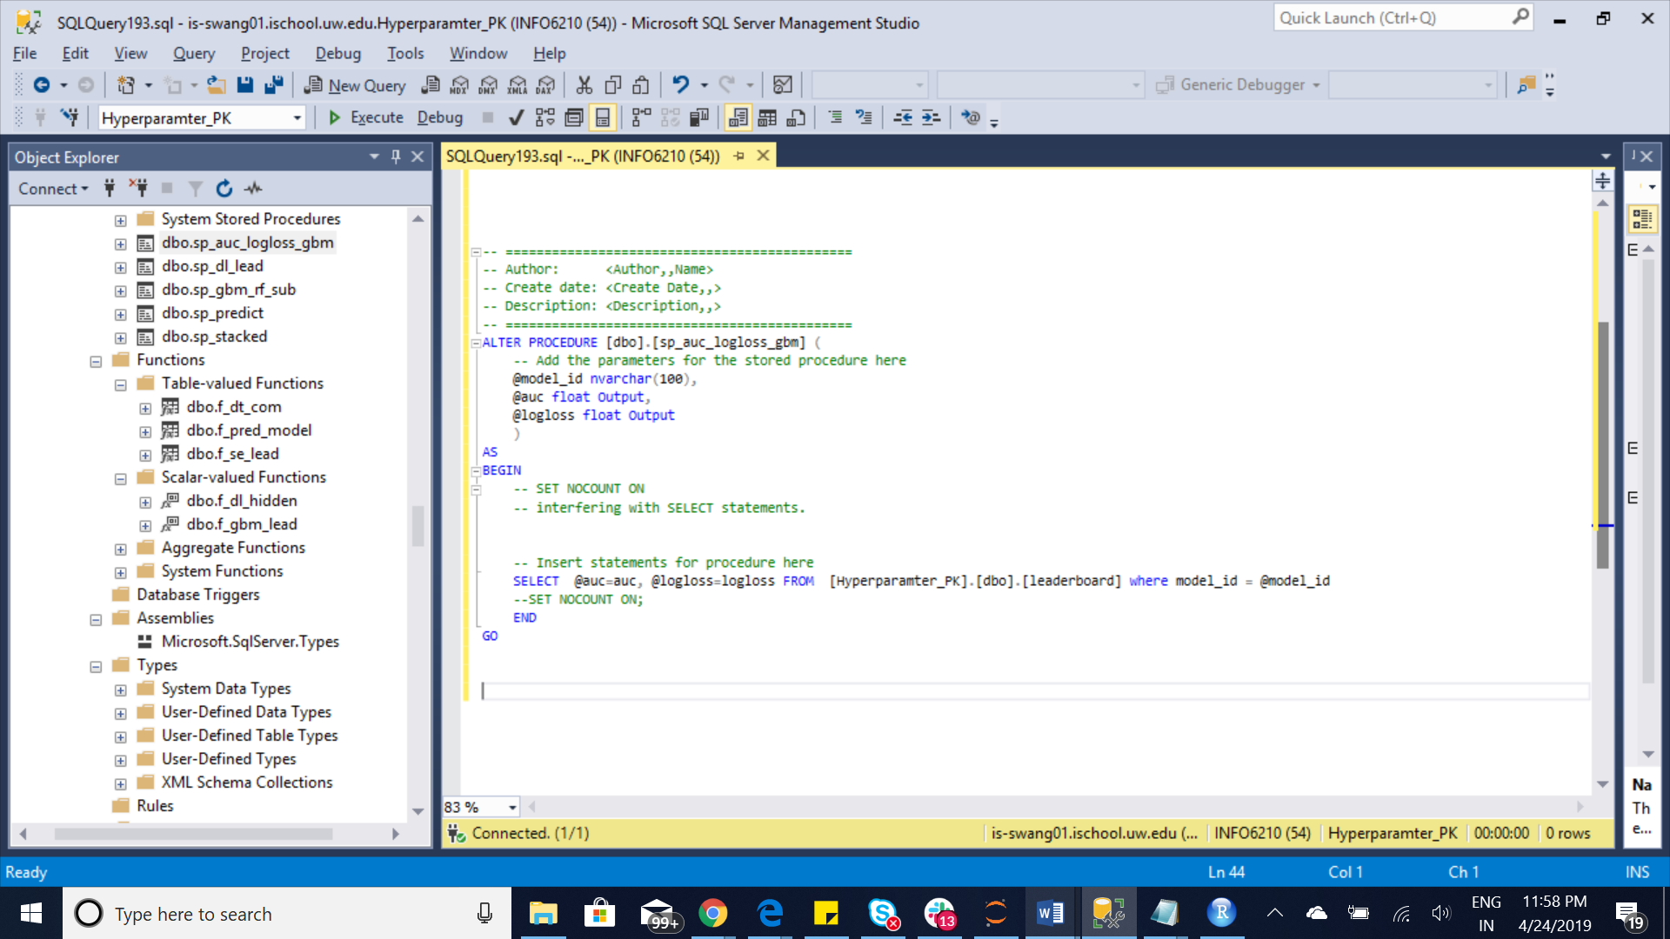

S. Procedure2: sp_dl_lead

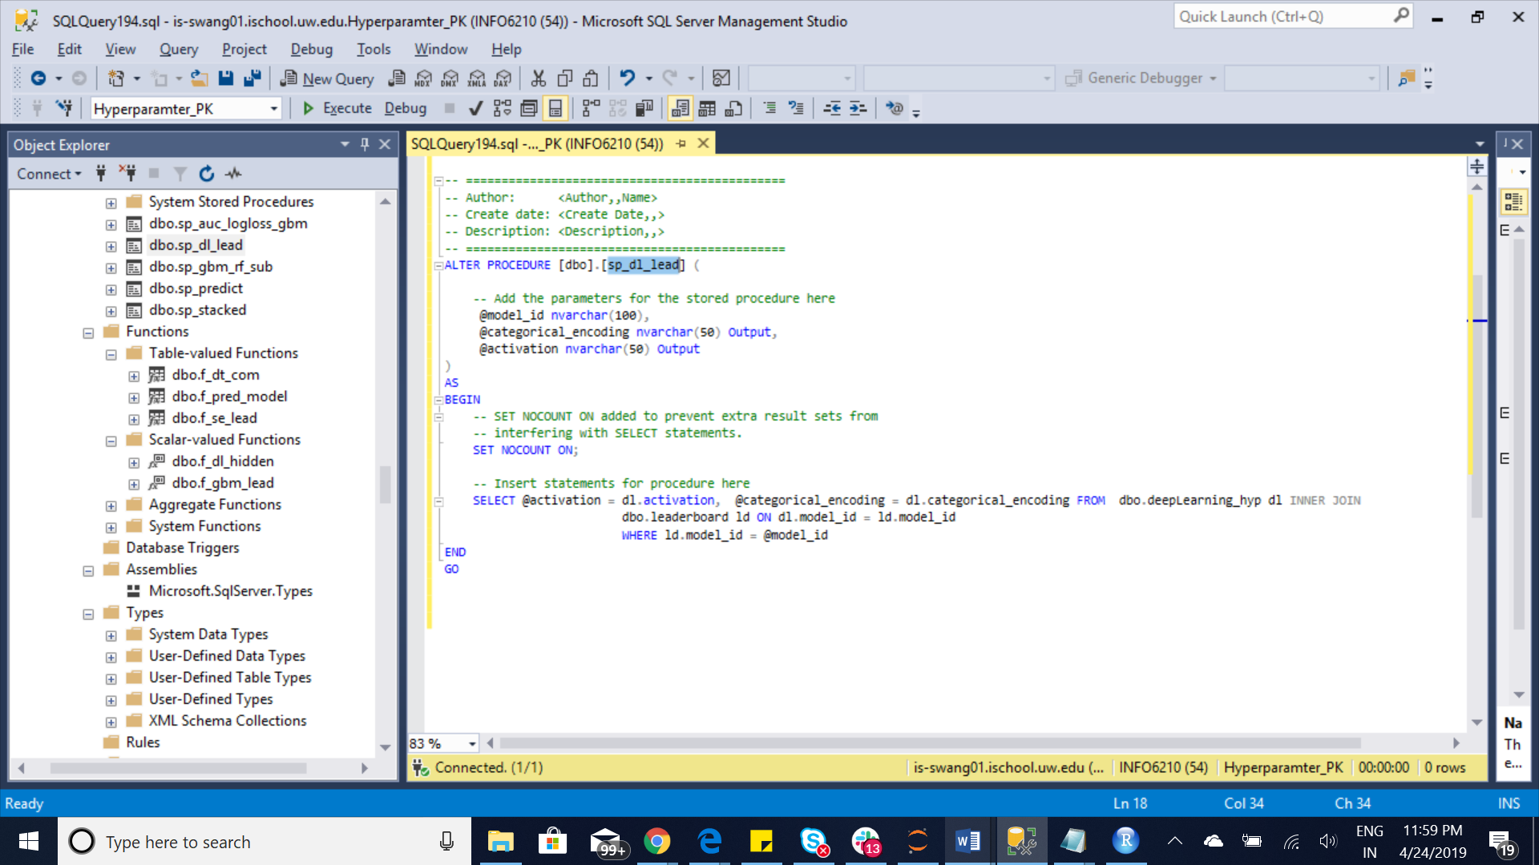

S.Procedure3: sp_gbm_rf_sub

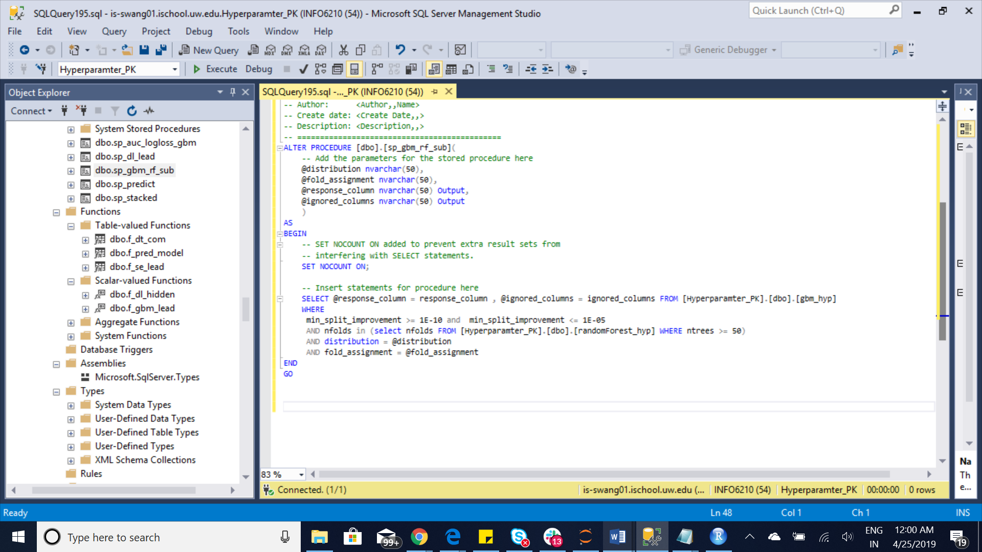

S.Procedure4: sp_predict

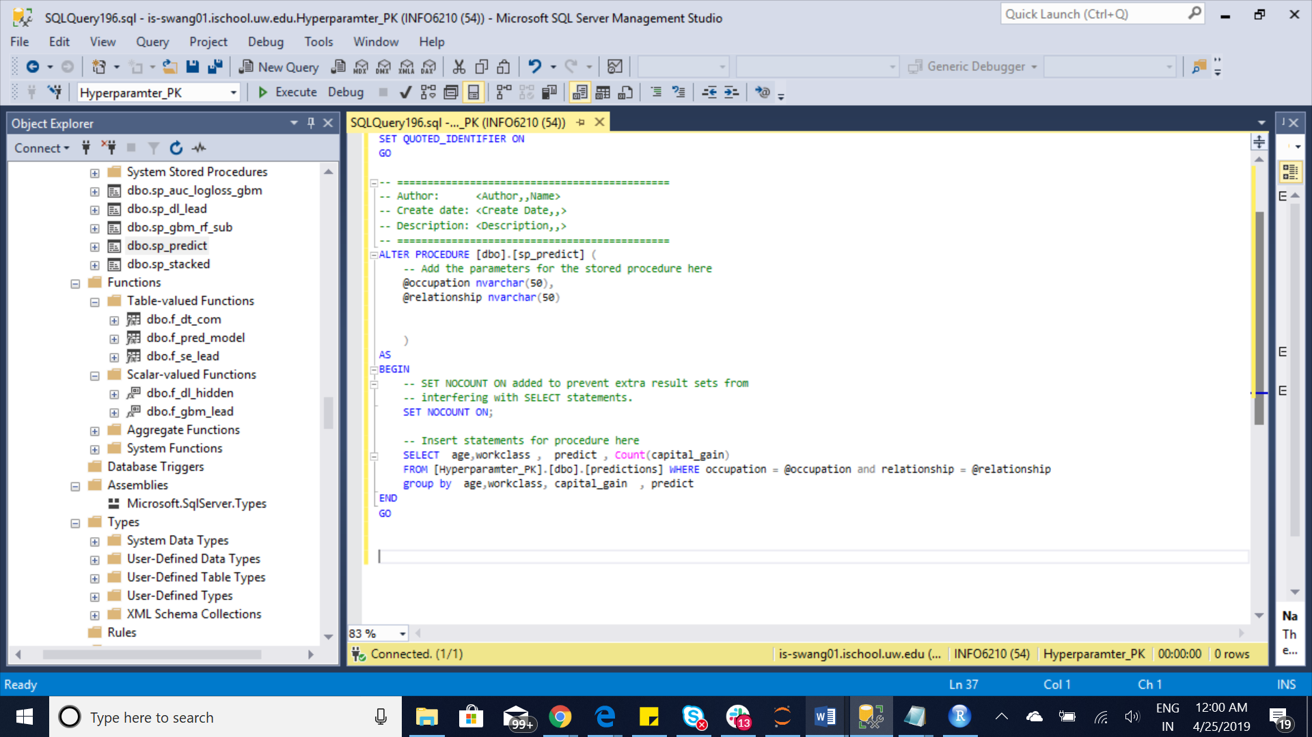

S. Procedure 5: sp_stacked

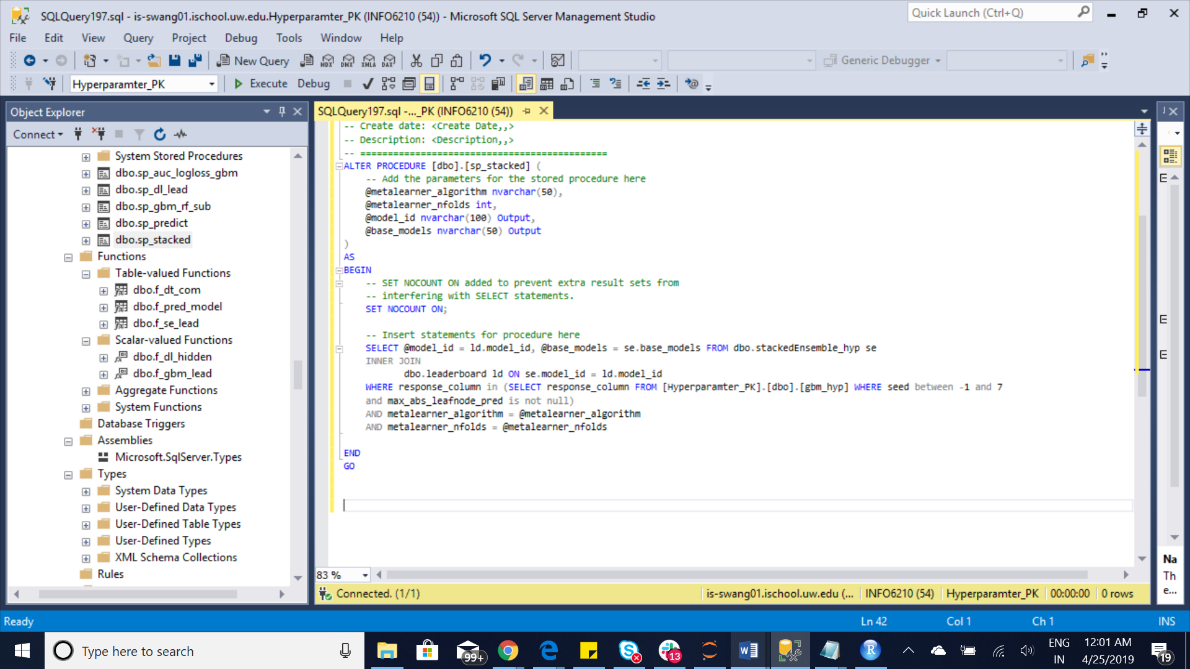

5 Indexs:

Index 1: ClusteredIndex-rf

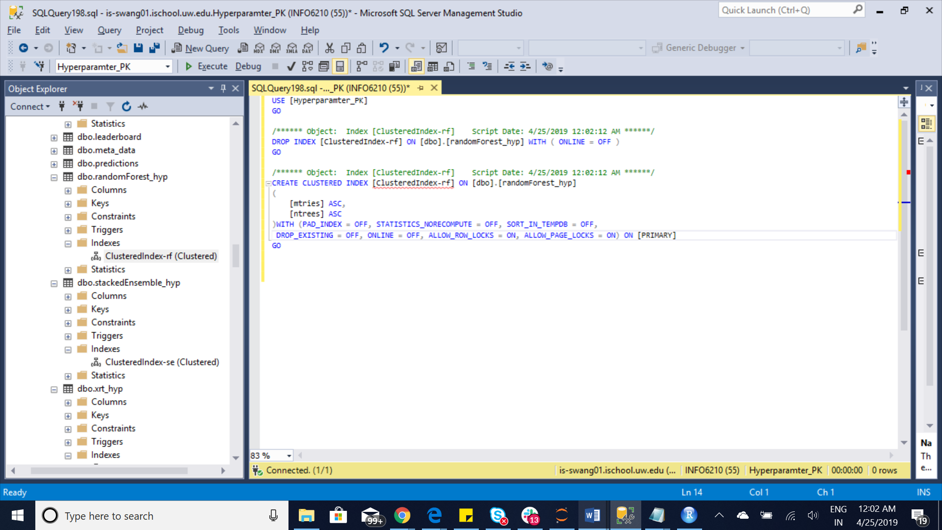

Index2: ClusteredIndex-se

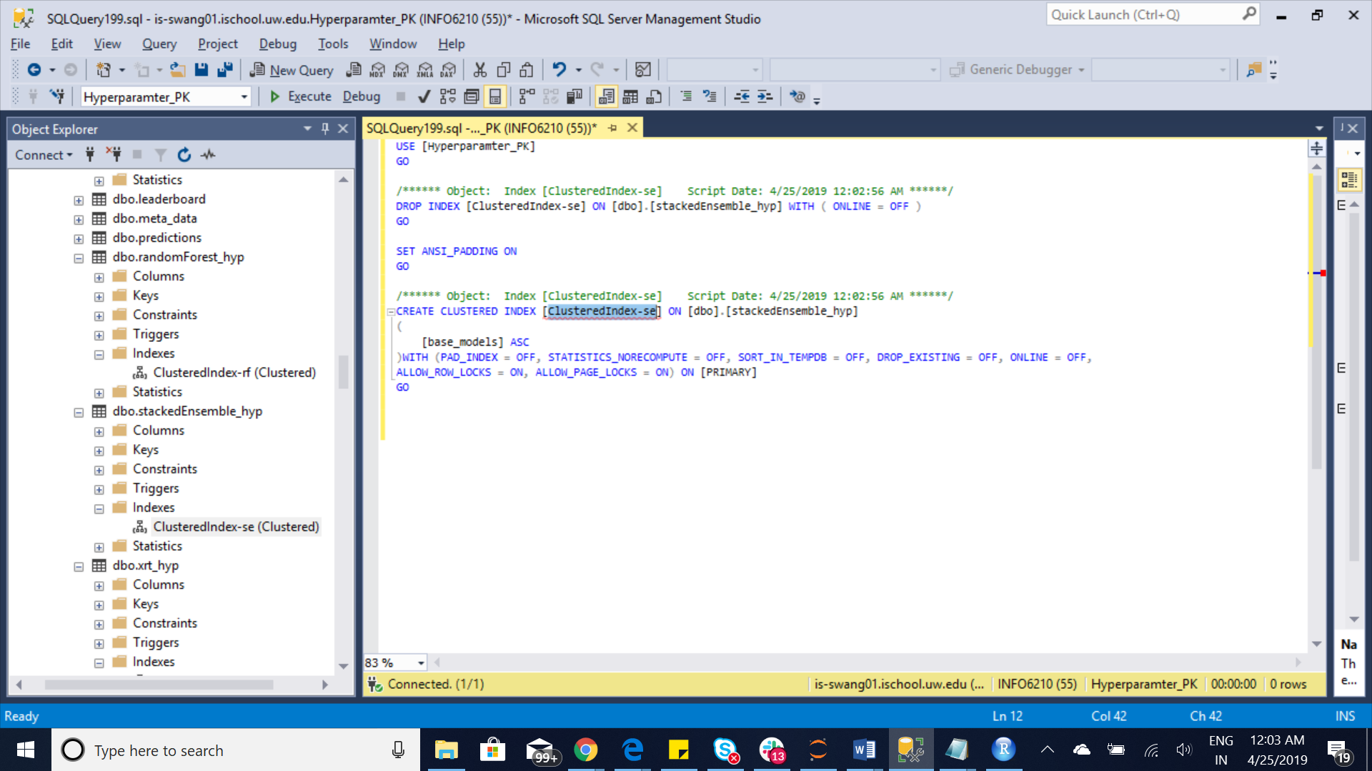

Index3: ClusteredIndex-xr

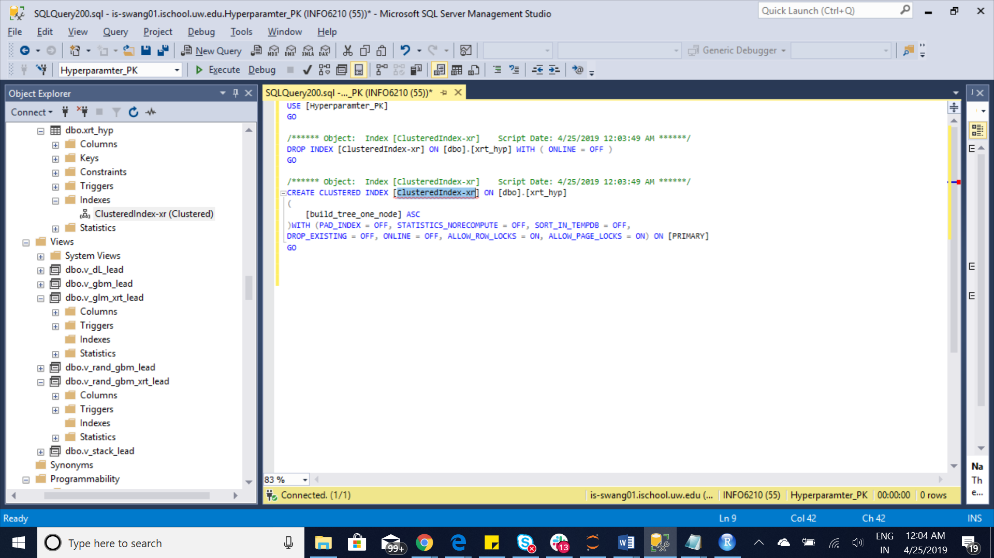

Index4: [ClusteredIndex-md]

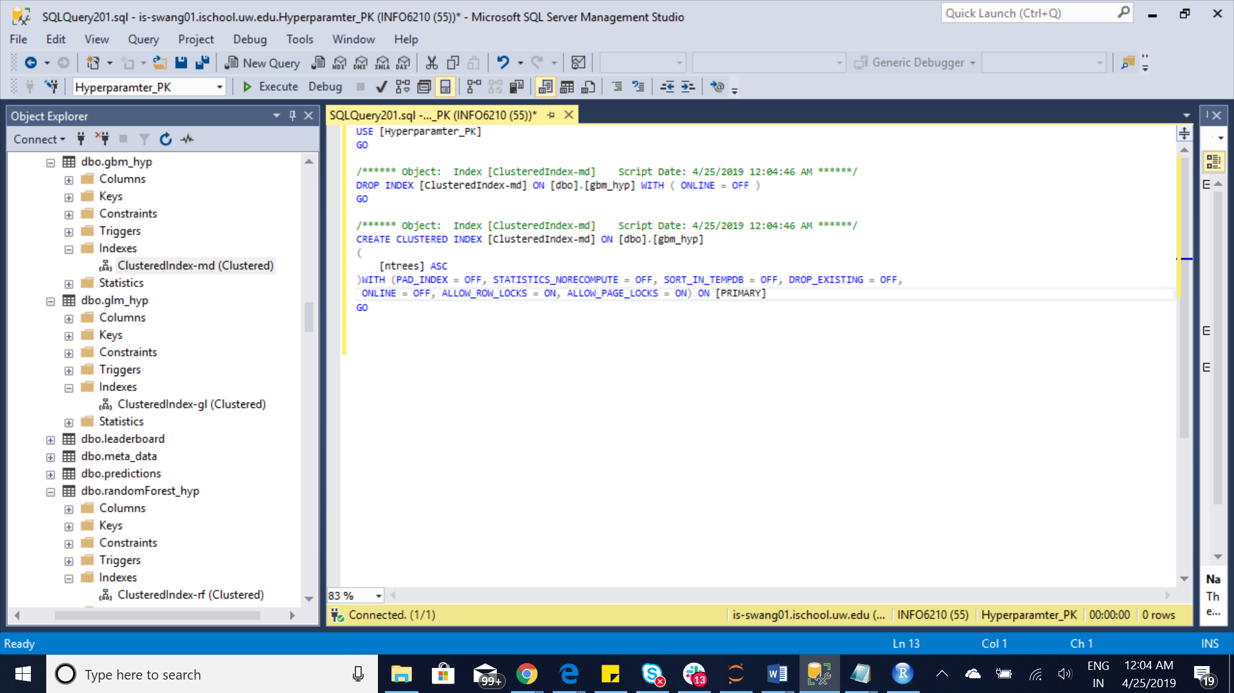

Index5: ClusteredIndex-gl

